NAME: M.Greeshma
COURSE: Design and Analysis of Algorithms
CODE: CSA0619
REPORT
Q23.Minimum Number of Jumps
Given an array where each element represents the maximum number of steps that can be
taken forward, determine the minimum number of jumps required to reach the last index. The
goal is to minimize the number of moves while ensuring reachability. Use Dynamic
Programming or Greedy techniques to compute the optimal solution.
Input Format:
n = number of elements
arr[] = jump values
Sample Input:
n = 5
arr = 2 3 1 1 4
Expected Output:
Min Jumps = 2

Sol :
Optimal Code (Greedy, O(n) time)
def min_jumps(arr):
n = len(arr)
if n <= 1:
return 0
if arr[0] == 0:
return float('inf') # cannot move

maxReach = arr[0]
steps = arr[0]
jumps = 1

for i in range(1, n):
if i == n - 1:
return jumps

maxReach = max(maxReach, i + arr[i])
steps -= 1

if steps == 0:
jumps += 1
if i >= maxReach:
return float('inf') # unreachable
steps = maxReach - i

return float('inf')

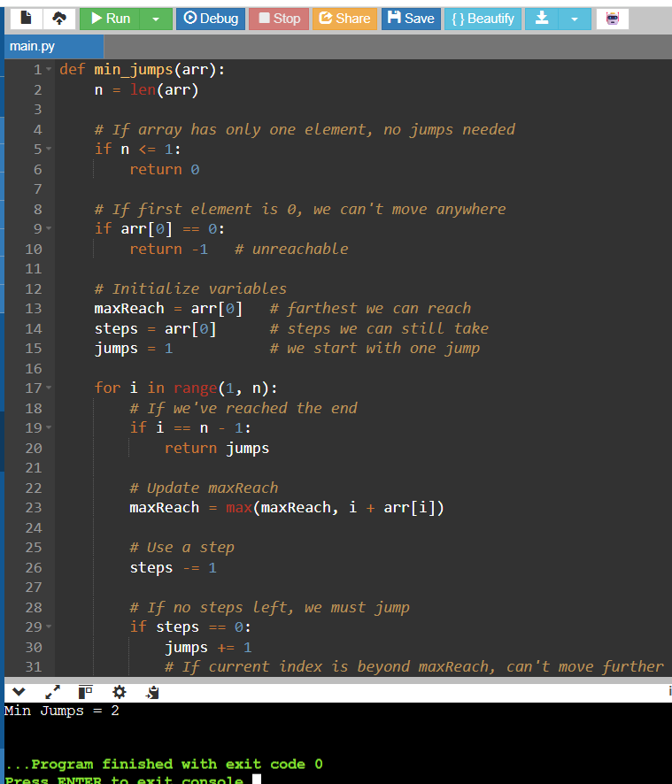

- Problem Definition
  - You are given an array where each element represents the maximum steps you can move forward from that position.
  - The task is to find the minimum number of jumps needed to reach the last index.
- Key Observations
  - Each element gives a "range of reachability."
  - The challenge is to minimize jumps while ensuring you don’t get stuck.
- Approaches
  - Dynamic Programming (DP):
    - Try all possible jumps from each index.
    - Store the minimum jumps needed to reach each position.
    - Time complexity: O(n²) (because for each index you may check all reachable indices).
  - Greedy Approach (Optimal):
    - Track the farthest index you can reach (maxReach).
    - Track how many steps you can still take before making another jump (steps).
    - When steps becomes 0, you must make a jump and reset steps to cover the next range.
    - Time complexity: O(n).
- Variables in Greedy Solution
  - maxReach: The farthest index reachable at any point.
  - steps: Remaining steps before you must jump.
  - jumps: Number of jumps taken so far.
- Algorithm Flow
  - Start with jumps = 1 (since you must jump from the first element).
  - Iterate through the array:
    - Update maxReach with the farthest index reachable.
    - Decrease steps by 1.
    - If steps == 0, increment jumps and reset steps = maxReach - currentIndex.
  - If you reach the last index, return jumps.
- Edge Cases
  - If the array has only one element → 0 jumps.
  - If the first element is 0 → unreachable (-1).
  - If at any point i >= maxReach → unreachable.
COMPARISON

